Computer Vision Homework 3

Name: 黃新予

Student ID: f08922136

1. **Environment Setup  
   Language: Python 3 (on jupyter)  
   Library: numpy, PIL, matplotlib**   
   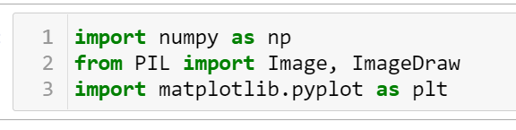
2. **Q1: original image and its histogram  
     
   Step 1: Read image using Image.open  
   Step 2: traverse all the elements and calculate the number of pixels in different intensity.  
   Step 3: use plt draw the histogram.   
     
   output image: original lena.bmp  
   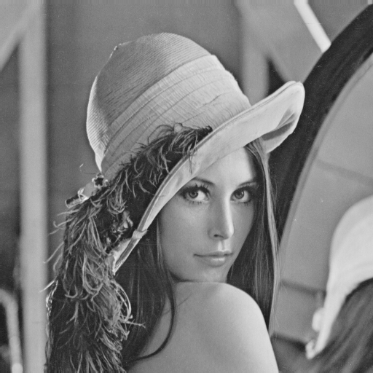**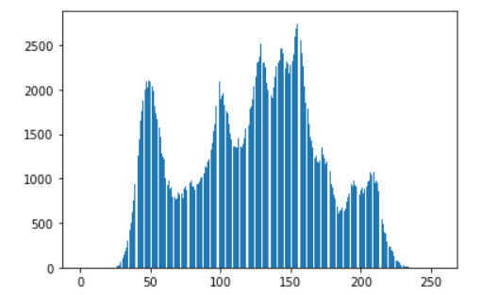  
   **code:**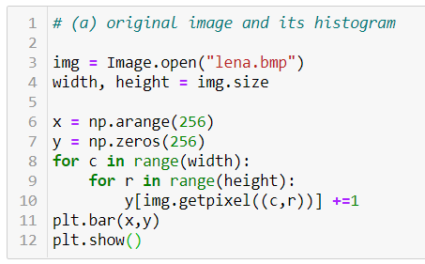
3. **Q2: image with intensity divided by 3 and its histogram  
     
   Step 1: read image using Image.open()  
   Step 2: traverse all the pixels, get pixel value, divided by 3 and calculate the number of pixels in different intensity.  
   Step 3: create a new image to store the new value divided by 3 from Step 2.  
   Step 3: use pyplot to draw histogram  
     
   output image**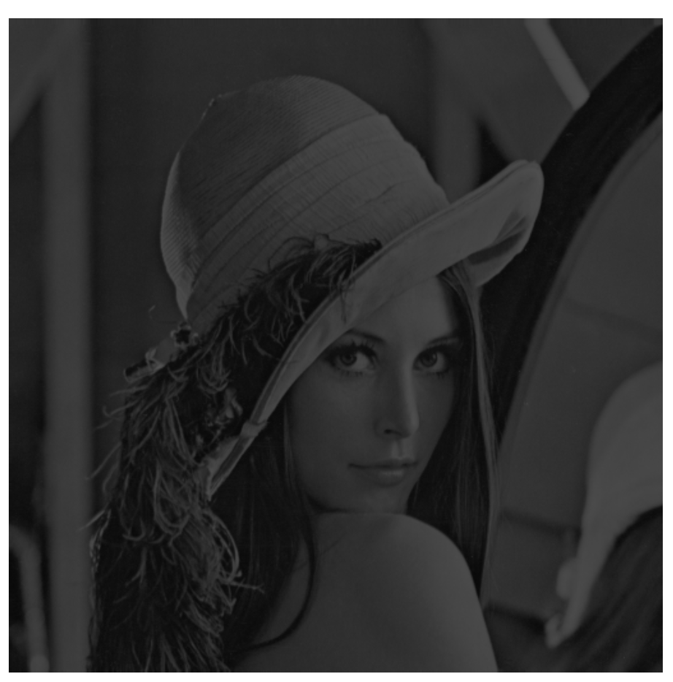 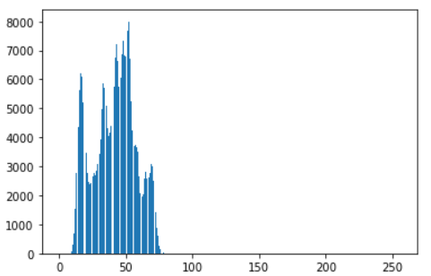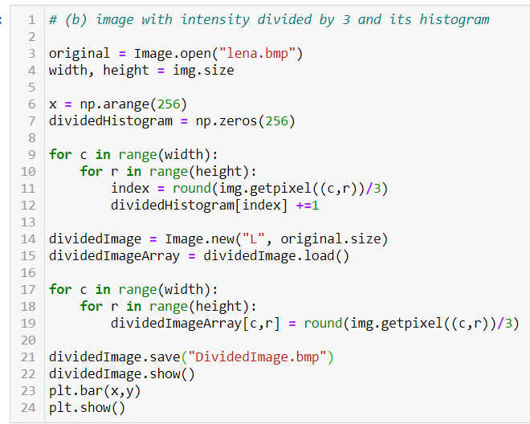
4. **Q3: image after applying histogram equalization to (b) and its histogram**   
   **Step 1: read image from (b) using Image.open()  
   Step 2: get divided image histogram count  
   Step 3: calculate the equalization histogram  
   Step 3: make new equalized Image**  
   **output image:**